Date of this BRS | 11-OCT-2018
Date Client Request Came through | 11-OCT-2018
Document | Business Requirement Specification
Document Number | CS-ID-KE-
ID SRM Log Number | Not Assigned yet
Client | BCD TRAVEL LTD
Requirement | TICKET LOADING LOGIC
Client Contact / Requested By | MR.NANDA
Current Running Version | ETRAVEL – V3.0
Prepared By | Moaga Ben, +254736947225, samuelben@ke.infodynamic.net
Document Signed off Date by Client
Last Revision Inclusion in Brief
Requirement Specification | Global | Regional | Local | Customer Specific
 | NO | NO | NO | YES

Acronyms Used
BCD TRAVEL LTD | BCD TRAVEL LTD
IDKE | Information Dynamics – Kenya LLC

Section (A) – Requirement Specification
- Need to change ticket loading logic as follows
Current process flow
BCD has got one IATA number for both Safaricom and Bcd HQ (When ticket is issued the airfiles contains remarks such as customer codes, )
- The ticket first loads in BCD HQ, IF it contains remarks for customer code SO71,S0175 and SO177 THEN that ticket(s) is inserted to Safaricom’s schema(meaning same ticket is loaded in both BCD HQ and Safaricoms schemas)

New process flow
- Once the ticket contains remarks for this customer codes S071, S0175 and SO177, this codes are defined in schema KE041T3 common code. It should Load in Safaricom schema(KE071T3) and therefore should NOT load in BCDHQ schema(KE014T3)
- Bsp file loading shall be done in BCDHQ schema(KE014T3)
- On reconciliation the two schemas should be joined together based on Ticket airline(BSP)

- Load branch code in the following tables

- ID_TICKET_DETAILS_AIR
- ID_TICKET_DETAILS _BSP

- Billing Summary / Reco Summary and the Variance Reports should have the Branch code,These reports should have the branch wise and the consolidated options
The Process Level Changes (B)
Common code in BCD HQ schema
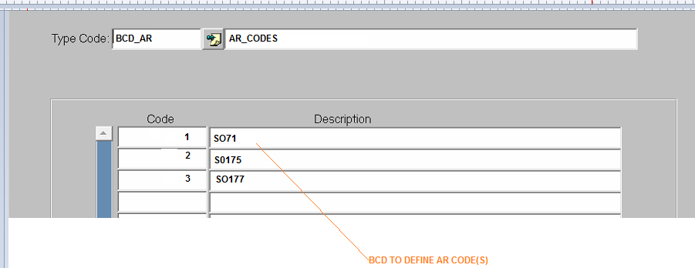

The GUI Level Changes (C)
- .Billing summary report : parameters and report
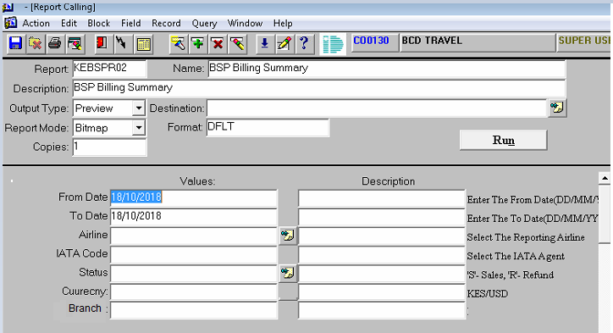
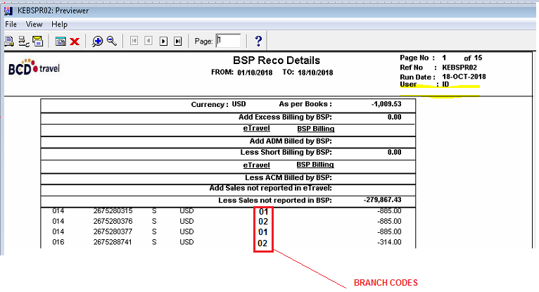
- Reco summary report : parameters and report
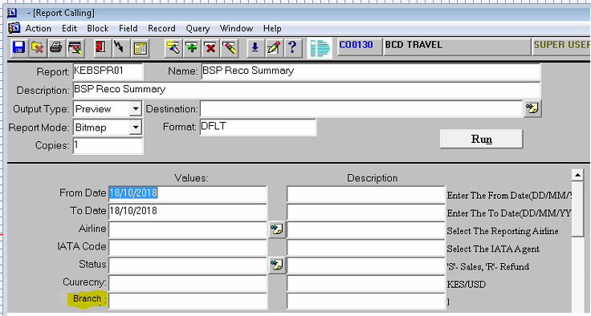

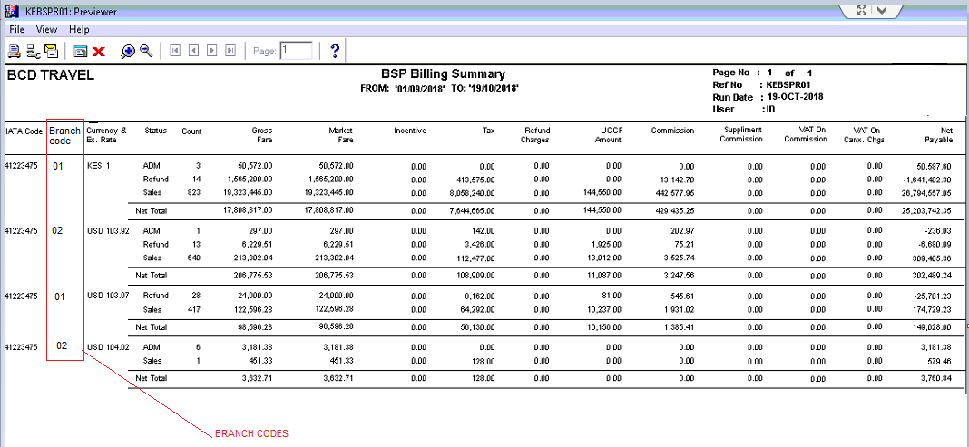

- Variance report : parameters and report

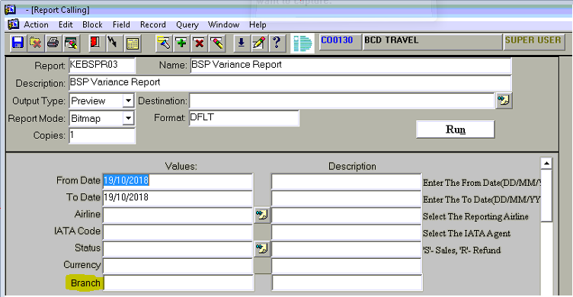
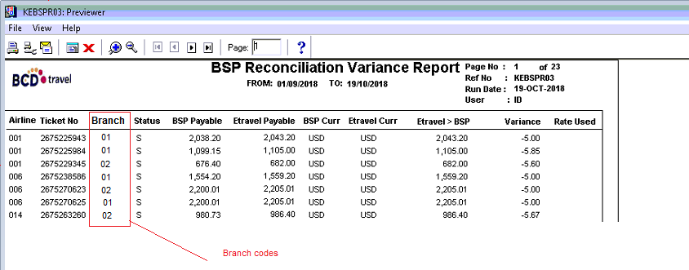

Test Cases (D)
Impact Analysis (E)
- Process Level Impacts
- Make additional changes to Report as described above
- Data Entry Impact
- None
- GUI Impacts
- None
- Reporting Impacts
- Adding elements to display as per the new GUI Image as shown above

- Financial / Posting level Impacts
- None
Table Reference | CP-001
(01). Requirement Analysis Schedule
- Responsibility Of | System Analysis Team – IDKE
- Scheduled Date of Analyzing Requirement
- Estimated Date of completion of Analyzing
- Queries on Requirement will be Raised on |  | - Estimated Date of Releasing the Man Days Required for Development
(02.) Schedule of Development
- Responsibility Of | Development In charge IDKE
- Man Days Required to Develop
- Estimated Date of Development Starting
- Estimated Date of Development Completion
- Scheduled Date of 1st Level Testing by Developer
- Estimated Date of Development Releasing to IDKE
(03). Schedule of Product Testing ( 2nd Level )/ Quality Control and Deployment
- Responsibility of | IDKE Product Handling and Implementation Department
- Estimated Date of IDKE Testing Start
- Estimated Date of IDKE Testing Completion
- Estimated Date of Product Release to Client Test Environment After QC/Testing
(04). Roll Out Schedule On Production Environment
- Responsibility of | Client
- Scheduled Date By Client for Testing
- ID support Required While Testing [Y/N]
- Estimated Date Testing Completion by Client
- Date t Product Signed off for Roll Out

