Date of this BRS
Date Client Request Came through
Document | Business Requirement Specification
Document Number | CS-ID-KE-001-
ID SRM Log Number | Not Assigned yet
Client | CWT Kenya
Requirement | AUTO-LOAD DETAILS FROM TRANSPORT MODULE TO MIS VOUCHER SALES SCREEN
Client Contact / Requested By
Current Running Version | None – V3.0
Prepared By | Margaret, +254739154200, samuelben@ke.infodynamic.net
Document Signed off Date by Client
Last Revision Inclusion in Brief
Requirement Specification | Global | Regional | Local | Customer Specific
 | NO | NO | NO | YES

Acronyms Used
CWT | BCD Travel
ID | Information Dynamics – Kenya LLC

Section (A) – Requirement Specification
- To load Data from Transport script with data dropping in a FTMS_IN table and loading the details in Miscellaneous Sales form KENYA021
- The data to be defined is
Seq | Data Column | Field Type | Field Size | eTravel Table Columns | eTravel | Remarks | Sample Value
1 | Ticket Number | Varchar2 | 10 | TICKET_NUMBER | Auto Generated | ID will generate automatically | M003036828
2 | Location | Number |  | TICKET_LOCATION | Validate Only | FTMS will use the 03 as the Location Code | 3
3 | Sales Branch | Number | 2 | TICKET_DEPARTMENT | Validate Only | FTMS will use 03 as the Sales Branch | 3
4 | Sales Date | Date | 11 | TICKET_DATE | Validate Only | Sales Date in DD-MMM-YYYY Template (Size should be 11 Characters with indicated delimiter | 25-Jan-18
5 | Currency | Varchar2 | 3 | TICKET_CURRENCY | Validate Only | currency code in 3 Characters, limited to KES and USD only, Always Uppercase | USD
6 | Travel Date | Date | 11 | TICKET_NEW_SALE_DATE | Validate Only | Pick Up Date in DD-MMM-YYYY Template (Size should be 11 Characters with indicated delimiter | 26-Jan-18
7 | Control Number | Varchar2 | 240 | TICKET_FLEX_V_2 | Validate Only | UNIQUE REFERENCE | 61348
8 | Sales Type | Varchar2 | 10 | TICKET_SALES_TYPE | Validate Only | Constant “TRANSFER” should be included, Always Uppercase | TRANSFER
9 | Pax Name | Varchar2 | 75 | TICKET_PAX_NAME | Validate Only | Passenger Name, always Uppercase | DAVID/RUTHO
10 | Customer 1 | Varchar2 | 10 | TICKET_CUSTOMER_1 | Validate Only | the Mapped Customer Code, always in Uppercase | C0075
11 | Booking Clerk | Varchar2 | 10 | TICKET_BOOKING_CLERK | Validate Only | the 2 Letter Mapped Code, all Uppercase | RK
12 | Executive | Varchar2 | 10 | TICKET_EXECUTIVE | Validate Only | the 2 letter mapped code, all in Uppercase | RK
13 | Agent Code | Varchar2 | 10 | TICKET_AGENT | Validate Only | the Supplier Mapped Code, Uppercase | KBR613
14 | Selling Fare | Number |  | TICKET_GROSS_FARE | No Validation | the Total Cost for the Booking as a Number | 2200
15 | Remarks | Varchar2 | 240 | TICKET_FLEX_V_1 | No Validation | Narration/remarks | From JKIA To Hilton Nairobi – Saloon Car
16 | Settlement Mode | Varchar2 | 10 | TICKET_MODE | Decode | All Bookings will be dropped as CREDIT | CREDIT
17 | LPO Number | Varchar2 | 50 | TICKET_LPO | No Validation | the Authorization code from FTMS | 256432
18 | LPO Date | Date |  | TICKET_LPO_DATE | No Validation | the LPO Date from FTMS | 22-Jan-18
19 | Booking Status | Varchar2 | 1 |  | No Validation | the Booking status O- Opened/Created, D-Driver Assigned, C – Completed, X-Cancelled, M-Modified (Wherever Booking Data is Modified) | O
20 | Cost Centre | Varchar2 |  | TMD_COST_CENTRE | NO Validation | Cost Centre for global reporting | 24043
21 | Project Number | Varchar2 |  | TMD_FLEX_V_4 | NO Validation | If Any element is missing the record will be coming appropriately as below with missing having null | 116
22 | Department Number | Varchar2 |  | TMD_FLEX_V_3 | NO Validation | 24043 / 116 / / TR / 3174329  In Above line Department Number is missing and hence; it comes as null , but the delimiter is there to identify the case | 28
23 | Trip Purpose | Varchar2 |  | TMD_PURPOSE | NO Validation | Trip purpose | TR
24 | Employee Number | Varchar2 |  | TMD_FLEX_V_19 | NO Validation |  | 3174329

- The Table name and column details for the FTMS_IN table are DEFINED as follows
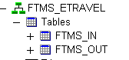
FTMS_IN Table Data Structure
ftms_etravel_type VARCHAR2(3) NOT NULL,
ftms_etravel_date DATE NOT NULL,
ftms_etravel_dataline VARCHAR2(500),
ftms_etravel_pick_flag VARCHAR2(1)
ftms_etravel_ticket_number NUMBER
ftms_etravel_error VARCHAR2(240)

- Requirement is to define object - PROCEDURE to load data from the FTMS_IN table into id_ticket_details,id_ticket_stock_master and id_ticket_more_details_mmi by matching entries as defined below on the GUI sections
The Process Level Changes (B)
- Auto Load Transfer details through a defined interface into eTravel System
- Only Booking Status ‘C’ details to be picked from ftms_etravel_dataline column in a FTMS_IN table and be loaded on Miscellaneous sales From (KENYA021) after standard data validation then, eTravel User to create Invoice after confirmation of data.
- ftms_etravel_dataline column is having all details with Pipe delimited , eTravel need to decode the value and load in respective column in main tables for booking status ‘C’
03|03|25-JAN-2018|USD|26-JAN-2018|61348|TRANSFER|DAVID RUTHO|C0075|RK|RK|KBR613|2200| FROM JKIA TO HILTON NAIROBI – SALOON CAR|CREDIT|256432|22-JAN-2018|C|24043|116|028|TR|3174329
- If Validation fails on eTravel, then send the record to an exception table with remarks, user should be able to select such records and then transmit to live table after corrections, Additionally there will be a remarks column for the exception generated by eTravel as well.
- AIRLINE - For MIS transactions will be under AIRLINE MIS as per definition in AIRLINE_MASTER
- Ticket_number – AUTO-generated number for each transaction defined in car voucher from ID_NUMBER_GEN_SOURCE
- Based on Currency – ex.Rate will be defined picked from DAILY_EXCHANGE_RATE_MASTER
- Status – Will be a SALE with status ‘S’.
- Local/International will be local with status ‘L’
- In case if the LPO Number does not come in this field, i.e. if such is blank, then place the LPO as PENDING. And LPO date as sales date.
- Sector : sector1 will be default ‘NBO’

GUI Changes (C)
SAMPLE GUI CHANGES

A Sample Data Line from FTMS will look like below:
03|03|25-JAN-2018|USD|26-JAN-2018|61348|TRANSFER|DAVID RUTHO|C0075|RK|RK|KBR613|2200| FROM JKIA TO HILTON NAIROBI – SALOON CAR|CREDIT|256432|22-JAN-2018|C|24043|116|028|TR|3174329

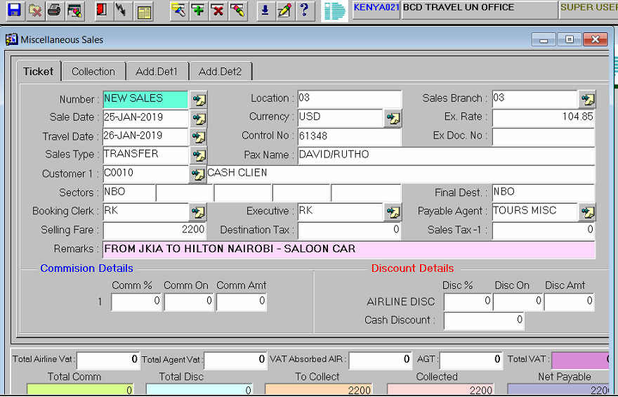
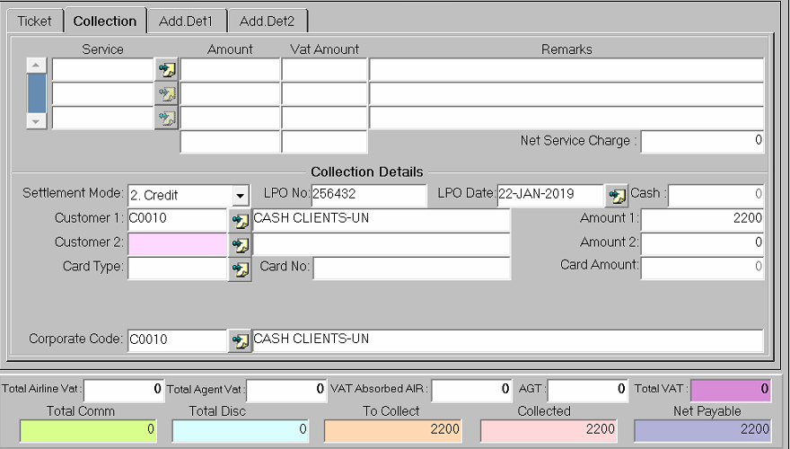
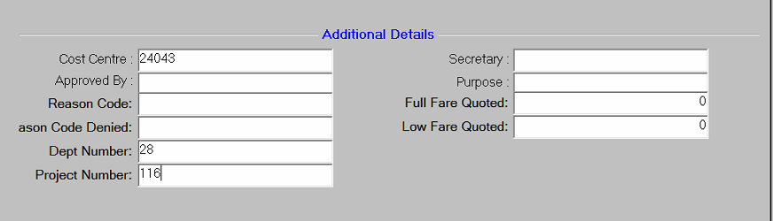

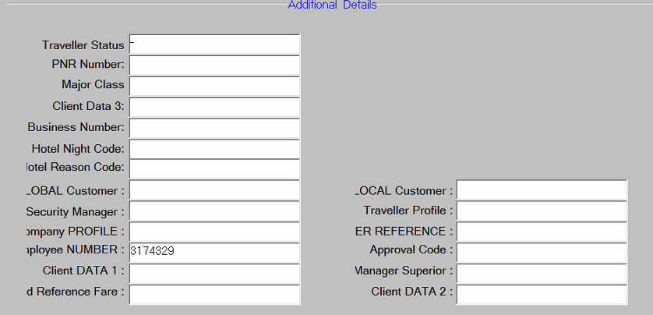S

D

Test Cases (D)
Impact Analysis (E)
- Process Level Impacts
- Data Entry Impacts
- GUI Impacts
- Reporting Impacts
- Financial / Posting level Impacts
Table Reference | CP-001
(01). Requirement Analysis Schedule
- Responsibility Of | System Analysis Team – IDKE
- Scheduled Date of Analyzing Requirement
- Estimated Date of completion of Analyzing
- Queries on Requirement will be Raised on |  | - Estimated Date of Releasing the Man Days Required for Development
(02.) Schedule of Development
- Responsibility Of | Development In charge IDKE
- Man Days Required to Develop
- Estimated Date of Development Starting
- Estimated Date of Development Completion
- Scheduled Date of 1st Level Testing by Developer
- Estimated Date of Development Releasing to IDKE
(03). Schedule of Product Testing ( 2nd Level )/ Quality Control and Deployment
- Responsibility of | IDKE Product Handling and Implementation Department
- Estimated Date of IDKE Testing Start
- Estimated Date of IDKE Testing Completion
- Estimated Date of Product Release to Client Test Environment After QC/Testing
(04). Roll Out Schedule On Production Environment
- Responsibility of | Client
- Scheduled Date By Client for Testing
- ID support Required While Testing [Y/N]
- Estimated Date Testing Completion by Client
- Date t Product Signed off for Roll Out

